**Rose Curve**

Parametric Equation for Rose Curve:

X = K * cos( n * θ ) * cos( n * θ )

Y = K * cos( n * θ ) * sin( n * θ )

Pseudocode for Drawing Curve: (including min-max ranges calcutaion)

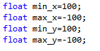

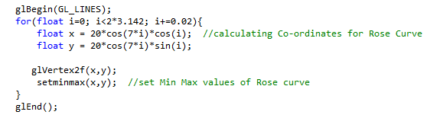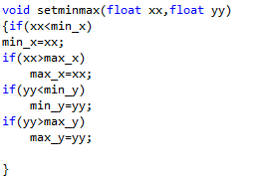

* 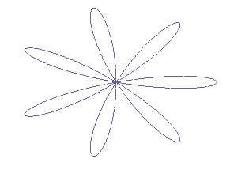This will draw rose curve with seven (7) petals having patel length of 20 units. Figure for this code is as following:

Now for sketching Bounding Box / Bounding circle, we will use min max values as support. Pseudocode for bounding box and bounding circle will be as :

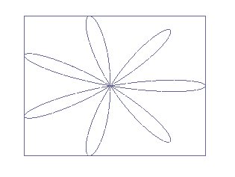

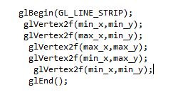**Bounding Box:**

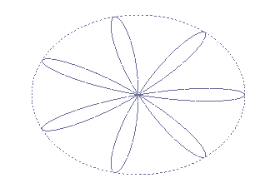

**Bounding Circle:**

